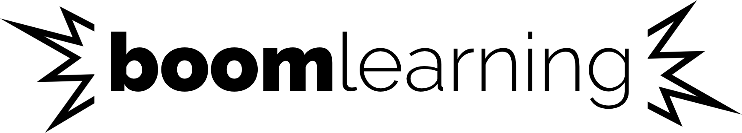

http://wow.boomlearning.com

OPT-IN PERMISSION SLIP

Boom Learning enables teachers to assign your student self-grading digital resources. Students who use Boom Learning receive immediate feedback and learn as they play.

Your teacher will provide Boom Learning with a nickname by which Boom Learning will recognize your child. You may contact your student’s teacher to change a nickname or user name if you feel the nickname provides too much information about your child. Your teacher will also share with us which resources are assigned to your student. You may contact your teacher at any time to revoke permission. Revoking permission will result in all your student’s performance data being deleted and is not reversible.

When your student engages with a resource, we provide your teacher with immediate feedback about how your student performed, including answers selected (correct and incorrect) and time spent on each task. Your student and you can also see these results from the student dashboard. You can use the print or print to .pdf features of your device to save copies of student reports.

To allow your student to use Boom Learning in the classroom, please complete this form and return it to your teacher. The purpose of allowing your student to opt-in is to benefit your student’s education. You are agreeing to the Boom Learning Privacy Policy (https://wow.boomlearning.com/privacy) by opting-in.

Student Name:

Parent or Guardian Name:

Signature: Date:

Educator Name:

School Name:

